**SECURIN**

**DHARSHANA SHRI P**

**3rd Year CS Student**

**SVCE**

**GITHUB LINK :** [**https://github.com/ShriDharshana25/Doomed_Dice**](https://github.com/ShriDharshana25/Doomed_Dice)

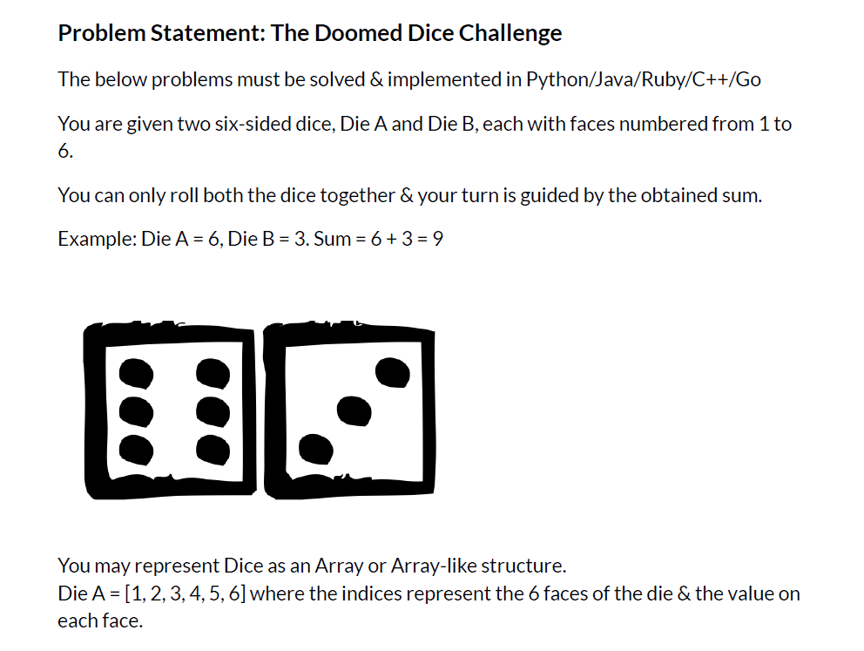

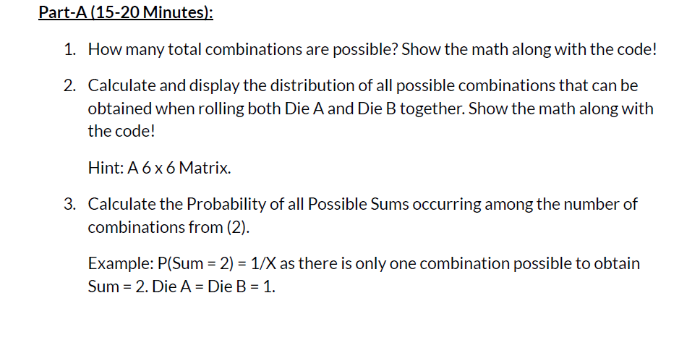

1.

Need to find the count of total number of possibilities

This can also be done by squaring the number of possibilities of a single dice sides . So, that the Total_combinations=36

2.

Create a two dimensional array for the distribution of all possible combinations

Using the for loop and arithmetic operators, calculate the value for the die_a and die_b

Assign the possible combinations of two dice to the distribution matrix and print the combination using the for loop

3.

The sum of all combination must be between 2 to 9

If the sum of two dices equal to any number between 2 to 9 , count should be incremented

And print the possible combination along with the sum and probability

Probability=count/total_combinations

Part_A_Solution.py

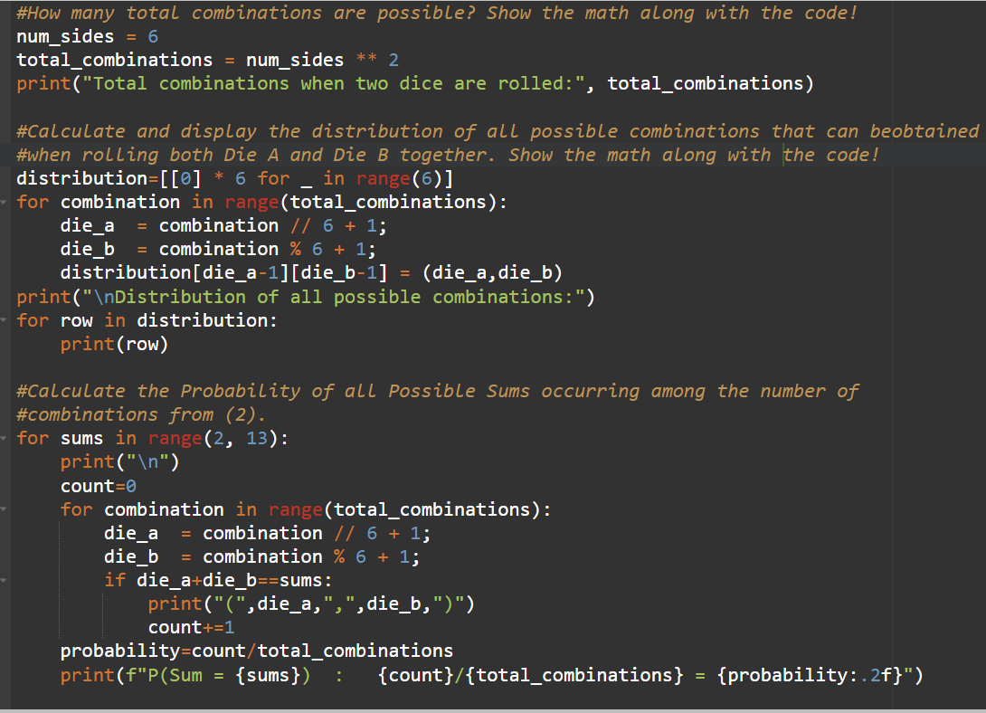

OUTPUT:

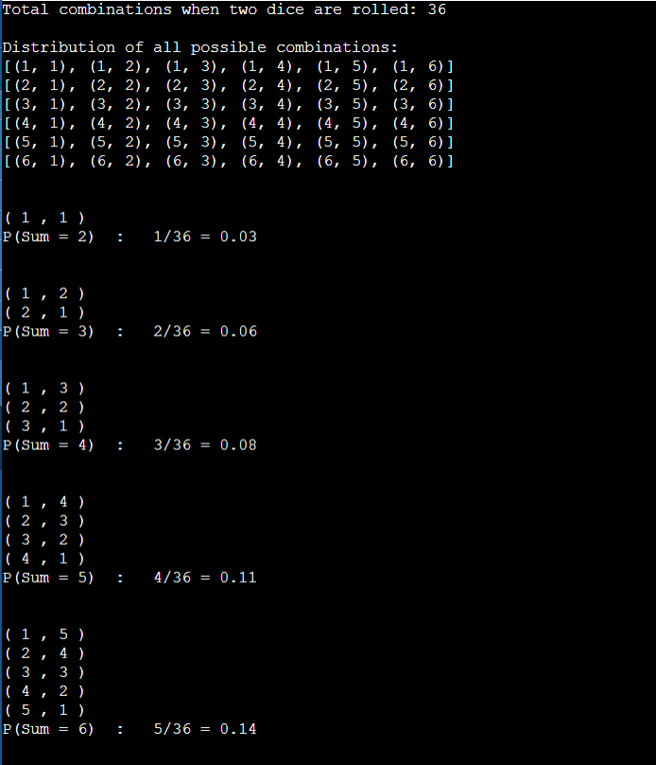

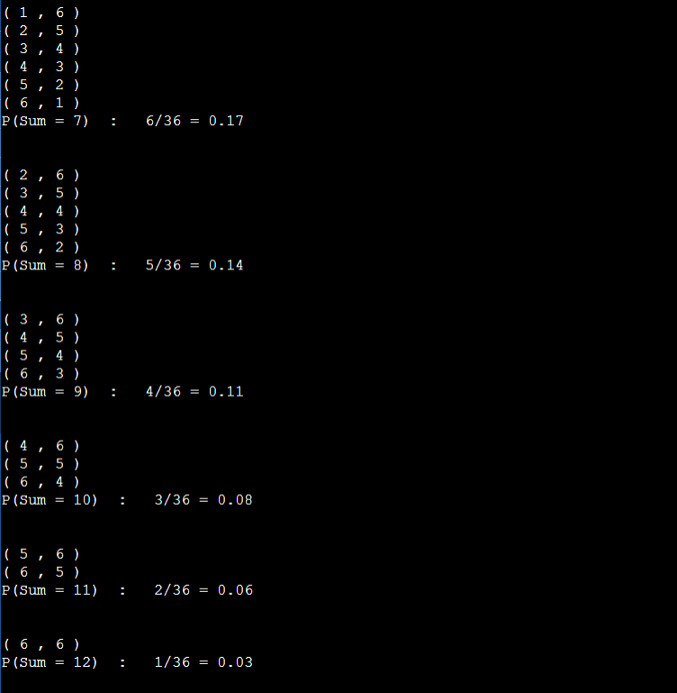

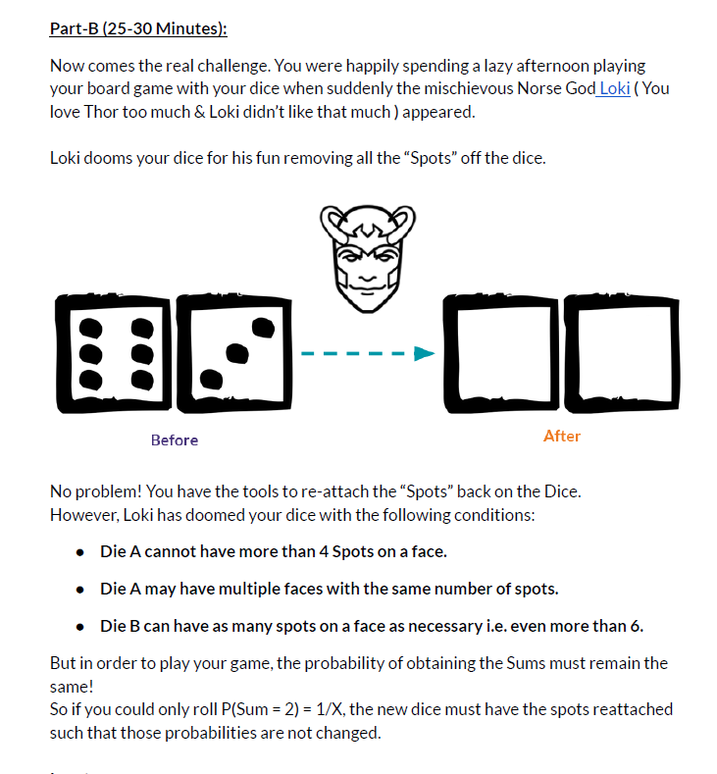

1.

Need to find the count of total number of possibilities

This can also be done by multiplying the length of the two dice Die_A and Die_B

Initially,

die_a=[1,2,3,4,5,6]

die_a=die_b

2.

Using for loop, find the sum of the combination two dice (Die_A , Die_B)and count of the sum and print the sum, count and probability for this original dice

Assign the sum and count to the dictionary variable (original_sums)

Assign the original_sums to the new_sums

3.

Create a two functions for DiceA_possibility and DiceB_possibility

Create a function for Undoom_dice , if an Undoom_dice function call, it calls the DiceA_possibility function to get the list for DiceA between 1 to 4 because DiceA cannot have more than 4 spots on the face and calls the DiceB_possibility function to get the list for DiceB between 1 to 11 because the total sum of two dice is 12.

4.

Check the sum of the combination two dice (DiceA,Dice_B) and count of the sum equals to the sum and count which is in the new_sums

If its equal for all the combination of two list means return DiceA ,DiceB and the dictionary which contain the sum and count of the new two dice

Calculate and print the sum, count and probability for this new dice

Part_B_Solution.py

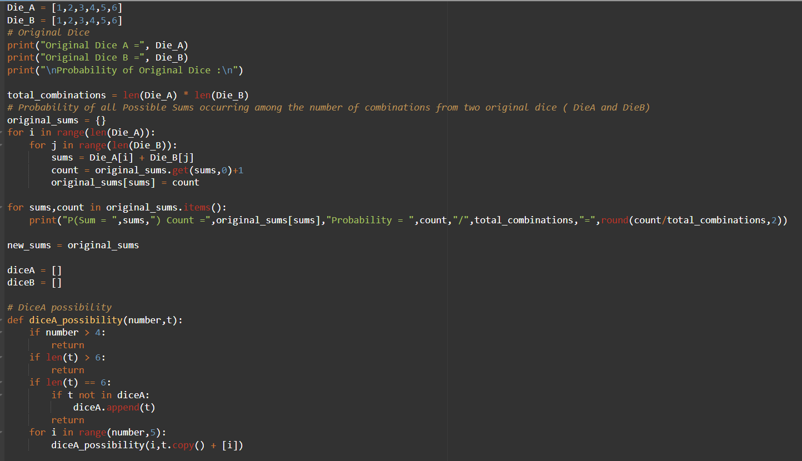

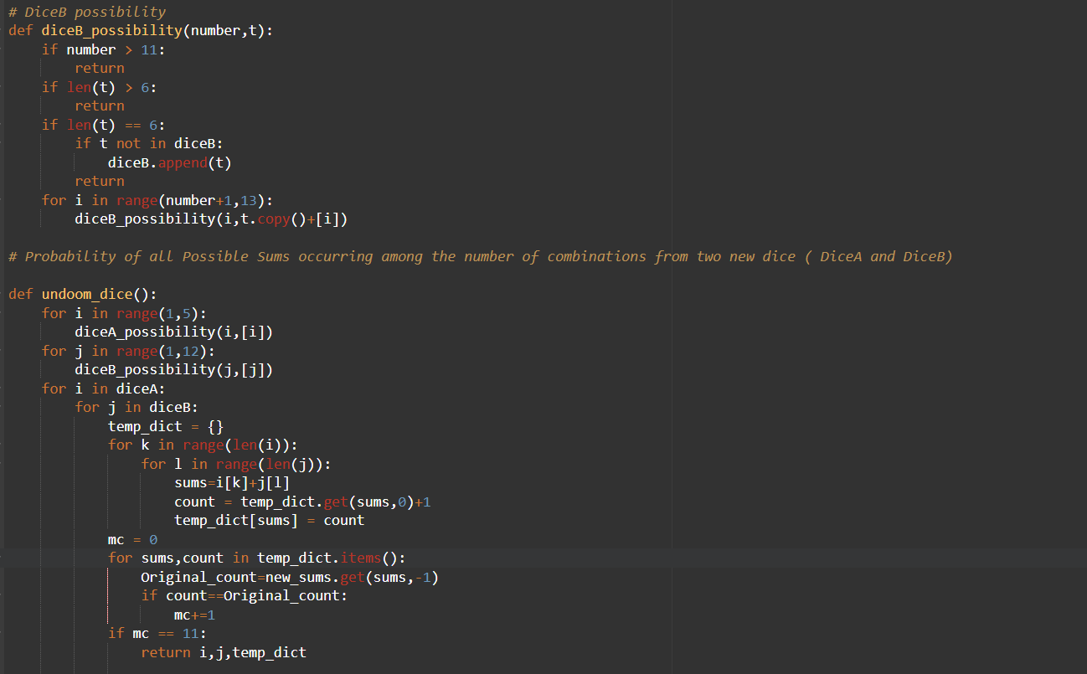

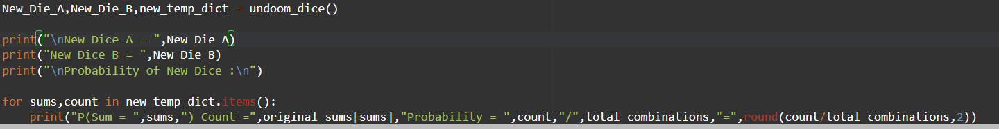

OUTPUT

